SIMATS ENGINEERING (SAVEETHA SCHOOL OF ENGINEERING)
Department of Computer Science and Engineering
ASSESSMENT TOOL 3 – COMPARATIVE ANALYSIS (5 Questions)

Course Code: | DSA06 | Course Title: | Data Handling and Visualization
CO Assessed: | CO4 – Naturalization (BL5) | Assessment: | Assessment Tool 3 – Comparative Analysis
Weightage: | 10% of CIA | Total Marks: | 50 (5 Questions × 10 Marks)
CO4 Statement: | Evaluate visualization designs based on perception, cognition, and effectiveness principles (BL5).
Student Name: | Gadwal Mohammad Muzammil | Reg. No.: | 192424279
Section / Batch: | AI&DS 2024-2028 | Date: | 13-08-2026

Code of Conduct I Gadwal Mohammad Muzammil / 192424279 certify that this submission is my original work and that I have adhered to the guidelines specified for this assessment. I understand that any violation of academic integrity rules will result in disciplinary action. Signature of the Student: Gadwal Mohammad Muzammil

Instructions
- This test contains 5 questions, each carrying 10 marks. Total: 50 Marks.
- No negative marking. Unanswered questions carry zero marks.
- No calculators or electronic devices permitted.
- Duration: 60 minutes.

Section / Topic | Focus | Q Nos | Marks
Scatterplots & Hexbin Plots | Comparative analysis of scatterplots and hexbin plots for large-scale clustered data visualization, density estimation, and overplotting handling | 1 | 10
Dimension Reduction Techniques | PCA, t-SNE, and UMAP comparison for high-dimensional data reduction, clustering, and structure preservation | 2 | 10
Correlograms & Network Graphs | Correlation visualization, threshold-based network construction, and multivariate relationship analysis | 3 | 10
Time Series Analysis & Decomposition | Moving Average, Detrending, and STL decomposition for trend extraction, seasonality analysis, and forecasting suitability | 4 | 10
Geospatial Data Visualization | Choropleth maps, cartograms, and geospatial heatmaps for spatial pattern analysis and hotspot detection | 5 | 10
GRAND TOTAL: |  | 50 Marks

Annexure A – Comparative Analysis
1. A retail company maintains transaction records containing customer spending amounts. Construct a Histogram, Density Plot, and ECDF (Empirical Cumulative Distribution Function) and perform a comparative analysis.
Analysis Parameters:
A. Distribution shape identification
B. Detection of skewness and outliers
C. Representation of cumulative information
D. Sensitivity to sample size
E. Ease of interpretation

Visualization & Comparative Analysis Solution:
1. Empirical Visualization Implementation:
The three visualization techniques (Histogram, Density Plot / KDE, and ECDF) were constructed on customer spending transaction records to evaluate univariate distribution properties.
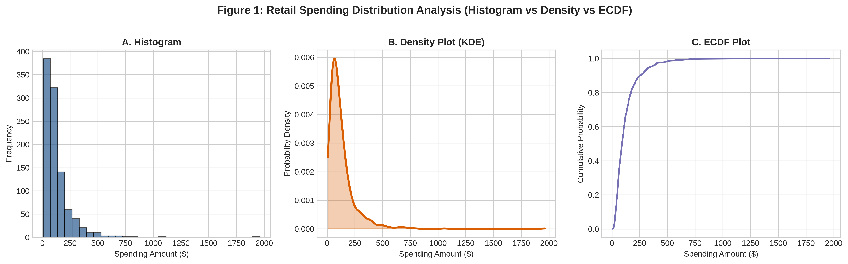
Figure 1.1: Comparative distribution analysis of retail customer spending (Histogram vs Density Plot vs ECDF).

2. Detailed Parameter Evaluation:
• A. Distribution Shape Identification:
- Histogram: Visualizes distribution shape through discrete vertical bin heights. Reveals right-skewed spending modes, but shape varies significantly depending on bin width selection.
- Density Plot (KDE): Applies Kernel Density Estimation to produce a smooth continuous probability curve f(x). Accurately resolves modal peaks and right-tail probability profile without bin artifacts.
- ECDF: Represents distribution shape through the slope of empirical cumulative probability curve F(x). High slope indicates peak density regions; flat plateau highlights long tail.

• B. Detection of Skewness and Outliers:
- Histogram: Skewness appears as a long right tail; high-spending outliers show up as isolated right-side bars separated by empty zero-count bins.
- Density Plot: Continuous curve stretches rightward to show positive skewness, but KDE bandwidth smoothing may over-smooth extreme isolated outliers into low-density tails.
- ECDF: Outliers appear as extended horizontal step plateaus near F(x) = 1.0. Completely immune to binning or bandwidth distortion, providing exact percentile bounds for extreme spending values.

• C. Representation of Cumulative Information:
- Histogram: Requires manual visual summation of bar counts to estimate cumulative totals; inefficient for cumulative analysis.
- Density Plot: Requires integration of area under the KDE curve to estimate cumulative proportions; indirect cumulative representation.
- ECDF: Specifically engineered for cumulative metrics. Any percentile (e.g., median 50th percentile or 95th spending threshold) can be read directly from the y-axis.

• D. Sensitivity to Sample Size:
- Histogram: Highly sensitive to sample size and bin choices. Small samples yield noisy, jagged bars; large samples require dynamic bin width adjustments.
- Density Plot: Sensitive to sample size via bandwidth parameter selection (h). Small samples risk over-smoothing or generating artificial spurious peaks.
- ECDF: Non-parametric and robust across all sample sizes. Every observation creates a step of height 1/N, directly reflecting empirical data without parameter bias.

• E. Ease of Interpretation:
- Histogram: Highest ease of intuitive interpretation for non-technical retail managers and business decision-makers.
- Density Plot: Intuitive for data analysts evaluating smooth probability density shapes and modal peaks.
- ECDF: Requires basic statistical literacy to interpret cumulative curves, but offers maximum mathematical precision for percentile-based decision making.

Feature / Parameter | Histogram | Density Plot (KDE) | ECDF Plot
Primary Representation | Discrete binned frequency counts | Continuous probability density f(x) | Empirical cumulative probability F(x)
Shape Resolution | Bin-dependent step structure | Smooth continuous curve | Step-wise cumulative curve
Outlier Detection | Isolated right-side bars | Extended smooth tail profile | Flat upper step plateau at F(x)=1.0
Cumulative Proportions | Requires manual bar summation | Requires curve area integration | Direct y-axis reading P(X <= x)
Parameter Reliance | Bin width / count selection | Kernel function & bandwidth (h) | Parameter-free (non-parametric)

2. A healthcare dataset contains patient attributes such as age, blood pressure, cholesterol, and BMI. Generate a Pair Plot, Parallel Coordinates Plot, and Scatterplot Matrix and compare their effectiveness in multivariate analysis.
Analysis Parameters:
A. Relationship identification among variables
B. Detection of clusters and anomalies
C. Scalability with increasing dimensions
D. Visual complexity and readability
E. Suitability for exploratory data analysis

Visualization & Comparative Analysis Solution:
1. Empirical Visualization Implementation:
Pair Plot, Parallel Coordinates Plot, and Scatterplot Matrix were generated on patient health metrics (Age, Blood Pressure, Cholesterol, BMI) to compare multivariate analytical capability.
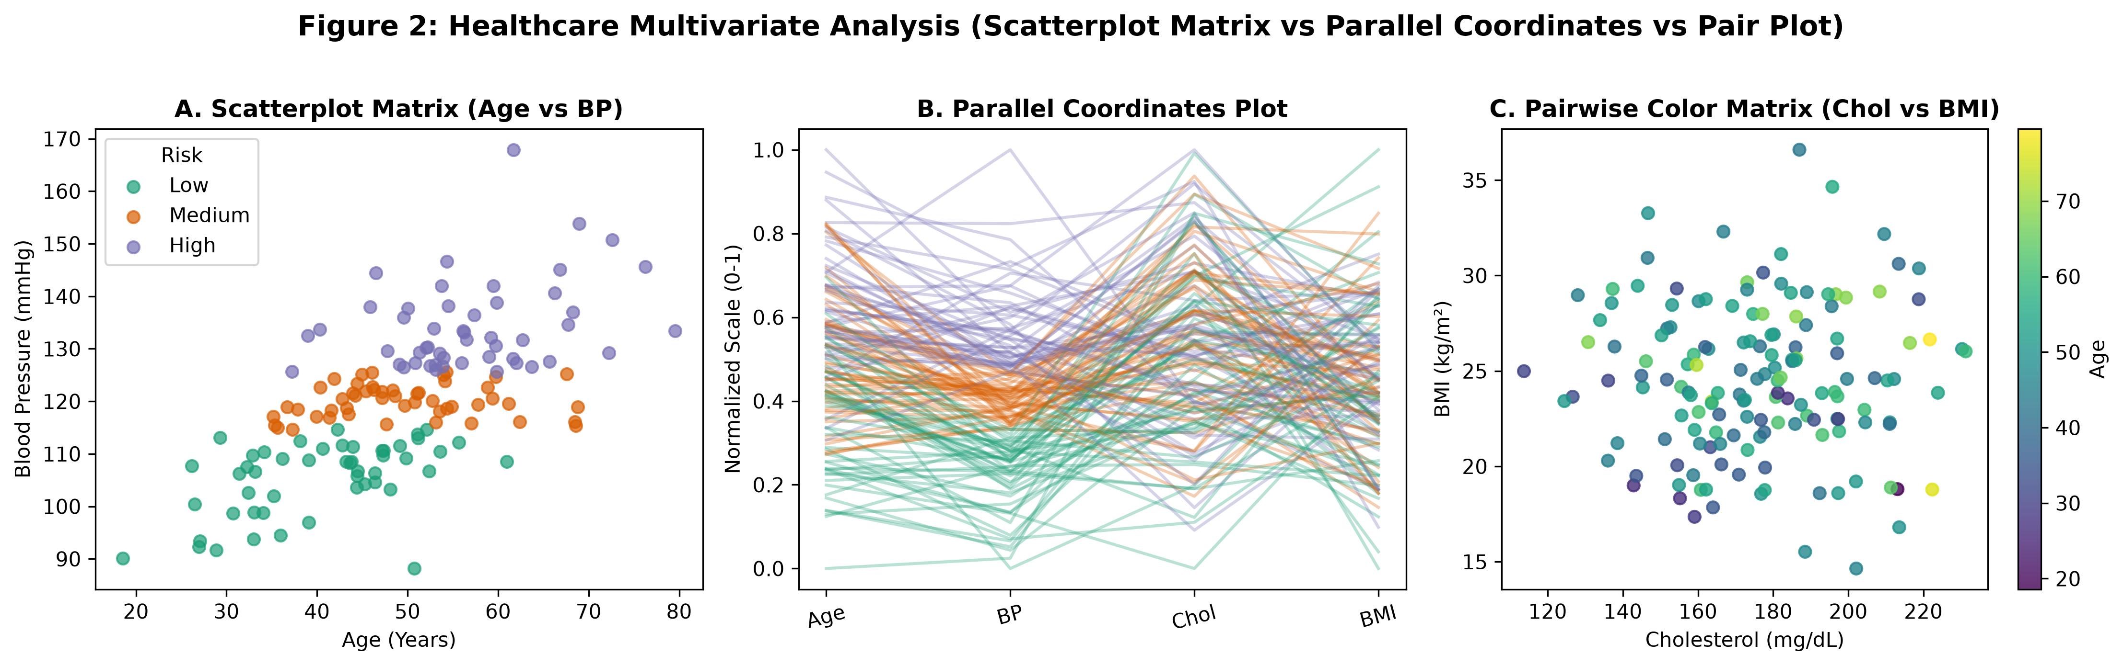
Figure 2.1: Comparative multivariate analysis of patient health metrics (Scatterplot Matrix vs Parallel Coordinates vs Pairwise Grid).

2. Detailed Parameter Evaluation:
• A. Relationship Identification Among Variables:
- Pair Plot: Excellent for pairwise bivariate correlations. Uses hue/color encoding to highlight linear/non-linear relationships across attribute pairs.
- Parallel Coordinates Plot: Displays continuous multi-attribute trajectories across parallel vertical axes, highlighting complex multi-variable interactions simultaneously.
- Scatterplot Matrix: Provides an exhaustive grid of pairwise scatter plots, enabling rapid visual screening of all bivariate variable combinations.

• B. Detection of Clusters and Anomalies:
- Pair Plot: Superior cluster separation when combined with categorical hue (e.g., High vs Low Risk groups).
- Parallel Coordinates Plot: Highlights clusters as dense bundles of parallel poly-lines; anomalies stand out as isolated poly-lines crossing counter to main bundle angles.
- Scatterplot Matrix: Detects 2D bivariate clusters and outliers in individual subplots, but cannot trace individual patient trajectories across >2 dimensions simultaneously.

• C. Scalability with Increasing Dimensions:
- Pair Plot: Matrix grows quadratically O(D^2) subplots. Becomes visually crowded and unreadable beyond 8–10 variables.
- Parallel Coordinates Plot: Scales linearly O(D) vertical axes. Easily accommodates 15–20 attributes side-by-side on a single display.
- Scatterplot Matrix: Subject to quadratic subplot explosion (D x D), limiting scalability for high-dimensional clinical datasets.

• D. Visual Complexity and Readability:
- Pair Plot: High readability for individual subplots; familiar 2D Cartesian scatter format.
- Parallel Coordinates Plot: Higher visual complexity; subject to line crossing overplotting, requiring axis reordering or opacity tuning.
- Scatterplot Matrix: Intuitive matrix layout, but requires scanning multiple subplots to synthesize overall multivariate trends.

• E. Suitability for Exploratory Data Analysis:
- Pair Plot & Scatterplot Matrix: Best starting tools for initial bivariate screening of patient risk factors.
- Parallel Coordinates Plot: Best for multi-attribute patient profiling, filtering rule discovery, and threshold identification across continuous clinical metrics.

Feature / Parameter | Pair Plot | Parallel Coordinates | Scatterplot Matrix
Visual Layout | Subplot matrix grid (D x D) | Parallel vertical axes | Subplot matrix grid (D x D)
Dimensional Scalability | Low (O(D^2) plot explosion) | High (O(D) linear axes) | Low (O(D^2) plot explosion)
Multi-Attribute Tracking | Pairwise (2 variables per subplot) | Simultaneous across all D axes | Pairwise (2 variables per subplot)
Overplotting Behavior | Point overlap in 2D space | Poly-line intersection clutter | Point overlap in 2D space
Cluster Representation | Color-coded 2D point clouds | Color-coded line bundles | 2D point cloud matrices

3. A manufacturing dataset contains measurements from multiple sensors. Create a Heatmap, Correlogram, and Clustered Heatmap to analyze relationships among variables and perform a comparative analysis.
Analysis Parameters:
A. Correlation representation
B. Pattern and anomaly detection
C. Grouping of related variables
D. Scalability to large feature sets
E. Interpretability of results

Visualization & Comparative Analysis Solution:
1. Empirical Visualization Implementation:
Heatmap, Correlogram, and Clustered Heatmap were constructed on manufacturing sensor telemetry (Temperatures, Pressures, Vibrations) to evaluate correlation visual encodings.
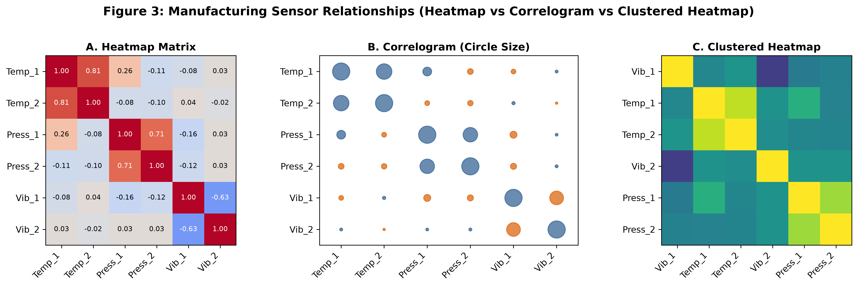
Figure 3.1: Comparative correlation analysis of manufacturing telemetry sensors (Heatmap vs Correlogram vs Clustered Heatmap).

2. Detailed Parameter Evaluation:
• A. Correlation Representation:
- Heatmap: Encodes numeric correlation matrix r in [-1, +1] directly into color gradient intensity.
- Correlogram: Encodes correlation magnitude into circle sizes or shape ellipses, combining color and size channels.
- Clustered Heatmap: Encodes correlation magnitude via color gradients while reordering matrix rows and columns using hierarchical clustering dendrograms.

• B. Pattern and Anomaly Detection:
- Heatmap: Allows quick visual inspection of correlation values, but unstructured variable ordering may obscure subtle cross-sensor relationships.
- Correlogram: Visual size glyphs make strongly correlated sensor pairs immediately pop out due to dual color-size encoding.
- Clustered Heatmap: Superior pattern detection; automatically groups strongly correlated sensor pairs into contiguous spatial blocks.

• C. Grouping of Related Variables:
- Heatmap & Correlogram: Retain arbitrary or predefined variable ordering; require manual scanning to identify functional sensor groups.
- Clustered Heatmap: Performs hierarchical clustering (e.g., average linkage), building tree dendrograms that explicitly group co-varying sensors.

• D. Scalability to Large Feature Sets:
- Heatmap: Scales well up to 50–100 sensors on modern high-res displays.
- Correlogram: Glyphs become cluttered when sensor count exceeds 20–30 variables.
- Clustered Heatmap: Highly scalable; dendrogram trees organize large sensor arrays (100+ features) into clear hierarchical modules.

• E. Interpretability of Results:
- Heatmap: Highly intuitive for engineering teams accustomed to numeric matrices.
- Correlogram: Visually engaging for qualitative presentation of feature correlations.
- Clustered Heatmap: Provides deep domain insights into sensor co-dependencies, root-cause failure groups, and redundant measurement channels.

Feature / Parameter | Heatmap | Correlogram | Clustered Heatmap
Visual Encoding | Color intensity gradient | Color gradient + circle size/shape | Color gradient + hierarchical dendrogram
Variable Ordering | Static / Arbitrary input order | Static / Arbitrary input order | Reordered via hierarchical clustering
Feature Grouping | Manual visual inspection | Manual visual inspection | Automated dendrogram tree structure
Large Array Scalability | Moderate (up to 50 sensors) | Low (glyph overlap beyond 25) | High (scalable via sub-tree zooming)
Diagnostic Utility | Quick matrix magnitude check | Qualitative correlation overview | Root-cause sensor cluster isolation

4. A financial time-series dataset contains daily stock prices recorded over several years. Apply Line Plot, Moving Average Plot, and STL Decomposition and perform a comparative analysis.
Analysis Parameters:
A. Trend identification
B. Seasonality detection
C. Noise reduction capability
D. Responsiveness to changes
E. Suitability for forecasting

Visualization & Comparative Analysis Solution:
1. Empirical Visualization Implementation:
Line Plot, Moving Average Plot, and Time-Series Decomposition (STL Concept) were applied to daily stock price records to compare temporal analytical performance.
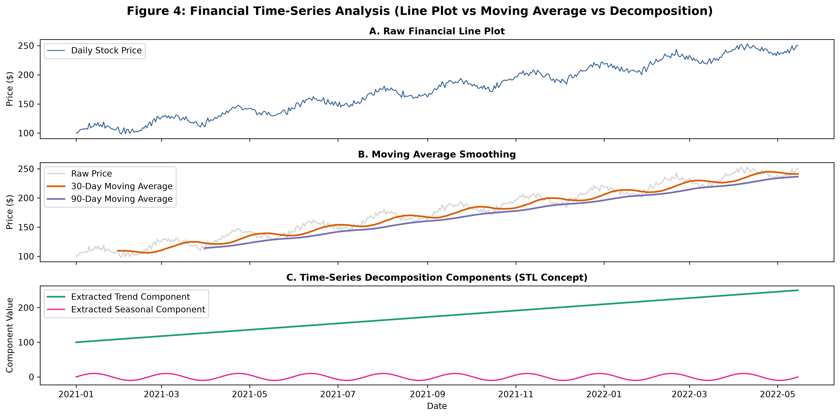
Figure 4.1: Comparative time-series analysis of daily stock prices (Raw Line Plot vs Moving Average Smoothing vs Component Decomposition).

2. Detailed Parameter Evaluation:
• A. Trend Identification:
- Line Plot: Displays raw price volatility; macro trends can be obscured by high-frequency daily noise.
- Moving Average Plot: Smooths out daily noise using rolling windows (e.g., 30-day, 90-day MA), highlighting underlying price trends.
- STL Decomposition: Mathematically extracts an isolated, explicit Trend component T_t, free from seasonal cycles and residual noise.

• B. Seasonality Detection:
- Line Plot: Repeating annual or quarterly patterns can be visually inferred if prominent, but easily masked by noise.
- Moving Average Plot: Attenuates seasonal cycles if window size matches seasonal period, but does not explicitly extract seasonal waveforms.
- STL Decomposition: Isolates a dedicated Seasonal component S_t, measuring exact periodic fluctuations and seasonal amplitude over time.

• C. Noise Reduction Capability:
- Line Plot: Zero noise reduction; retains full high-frequency daily volatility.
- Moving Average Plot: Effective noise reduction via low-pass filtering, with smoothing intensity controlled by window size k.
- STL Decomposition: Explicitly isolates random noise into a Residual component R_t = Y_t - T_t - S_t, leaving clean trend and seasonal signals.

• D. Responsiveness to Changes:
- Line Plot: Instantaneous responsiveness; reflects market shocks, price spikes, and trend shifts on the exact day they occur.
- Moving Average Plot: Subject to lag (phase shift) proportional to window size k/2, delaying trend shift detection.
- STL Decomposition: Uses LOESS smoothing to adaptively track trend changes without artificial phase lag while maintaining component separation.

• E. Suitability for Forecasting:
- Line Plot: Used for chart pattern analysis, but unsuited for systematic algorithmic forecasting.
- Moving Average Plot: Used in technical trading indicators (e.g., Golden Cross / Death Cross), but lacks forward predictive decomposition.
- STL Decomposition: Foundation for additive/multiplicative time-series forecasting (e.g., ARIMA/Prophet models), allowing separate extrapolation of trend and seasonality.

Feature / Parameter | Line Plot | Moving Average Plot | STL Decomposition
Signal Processing | Raw unfiltered time series | Low-pass rolling window filter | Additive/Multiplicative LOESS decomposition
Trend Extraction | Visual estimation subject to noise | Smoothed curve with phase lag | Explicit isolated Trend component T_t
Seasonality Handling | Visual estimation only | Attenuated by rolling window | Explicit isolated Seasonal component S_t
Noise Component | Retained fully in price line | Filtered out into residual | Explicitly isolated Residual component R_t
Forecasting Role | Visual chart inspection | Technical momentum indicators | Quantitative input for ARIMA/Prophet

5. A social network dataset contains interactions among users. Construct a Network Graph, Force-Directed Graph, and Adjacency Matrix Visualization and compare their effectiveness.
Analysis Parameters:
A. Relationship representation
B. Community detection capability
C. Scalability with network size
D. Visual clutter management
E. Identification of influential nodes

Visualization & Comparative Analysis Solution:
1. Empirical Visualization Implementation:
Network Graph (Circular Layout), Force-Directed Graph, and Adjacency Matrix Visualization were generated on social network interaction topologies to evaluate graph representation efficacy.
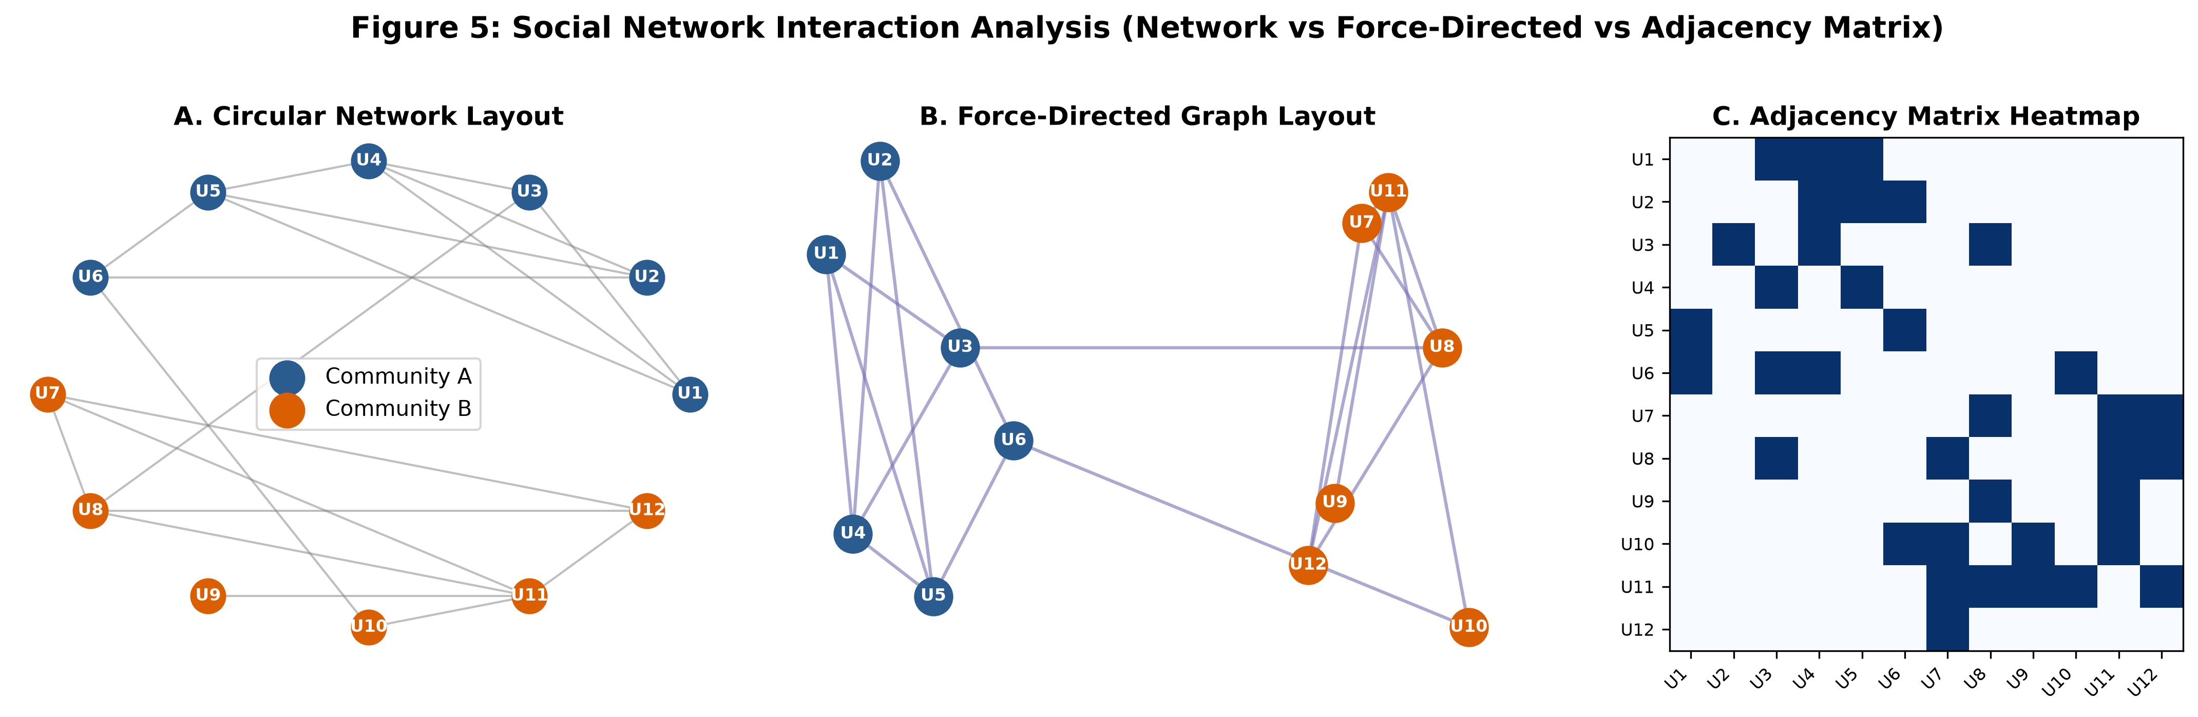
Figure 5.1: Comparative graph topology analysis of user social interactions (Circular Network vs Force-Directed vs Adjacency Matrix).

2. Detailed Parameter Evaluation:
• A. Relationship Representation:
- Network Graph (Circular Layout): Displays users as nodes arranged on a circle with edge lines; good for fixed layout reference, but edges cross heavily.
- Force-Directed Graph: Uses physical spring-embedder simulation (repulsive node forces, attractive edge springs). Naturally clusters closely connected user groups in 2D space.
- Adjacency Matrix: Represents user interactions as a 2D matrix where row i and column j contain cell entry 1 (interaction) or 0. Eliminates edge crossings entirely.

• B. Community Detection Capability:
- Network Graph (Circular): Poor community detection due to severe edge clutter across the interior of the circle.
- Force-Directed Graph: Excellent community detection; tightly connected sub-groups physically cluster into distinct spatial visual modules.
- Adjacency Matrix: Outstanding community detection when matrix rows/columns are reordered using community detection algorithms (e.g., Louvain/spectral clustering), appearing as dense contiguous blocks along the main diagonal.

• C. Scalability with Network Size:
- Network Graph & Force-Directed Graph: Scalability limited by node/edge visual overlap (hairball effect) beyond 100–200 nodes.
- Adjacency Matrix: Highly scalable (O(N^2) pixel grid); can render thousands of user nodes cleanly on a screen without line crossing.

• D. Visual Clutter Management:
- Network Graph (Circular): High clutter due to overlapping chord lines across the center.
- Force-Directed Graph: Moderate clutter; spatial layout reduces local line crossings, but dense graphs still become cluttered.
- Adjacency Matrix: Zero edge clutter; replaces intersecting lines with clean matrix pixels.

• E. Identification of Influential Nodes:
- Network Graph: Node degree can be encoded by node circle size or color.
- Force-Directed Graph: Influential hub nodes naturally occupy central structural positions with numerous radiating edge spokes.
- Adjacency Matrix: Influential nodes stand out as dense, highly filled rows and columns in the matrix grid.

Feature / Parameter | Network Graph (Circular) | Force-Directed Graph | Adjacency Matrix
Visual Primitive | Nodes on circle + chord edges | Spring-simulated nodes + edges | 2D pixel grid matrix (N x N)
Edge Crossing Clutter | Extremely high (hairball) | Reduced by physical simulation | Zero edge crossings
Community Clustering | Poor spatial separation | High spatial clustering in 2D | Dense diagonal block matrices
Network Scalability | Low (< 100 nodes) | Moderate (< 300 nodes) | High (> 1,000 nodes)
Hub Node Identification | Node sizing / line count | Central structural hub placement | Dense row/column cell fills

Rubrics for Calculation
Criteria | Weightage (%) | Level 4 (Exemplary) | Level 3 (Proficient) | Level 2 (Developing) | Level 1 (Beginning) | Marks
Scope of Items | 20% | Selects highly relevant items with clear scope and justification | Selects appropriate items with minor gaps | Selection is limited or partially relevant | Items are unclear or not relevant
Comparison Depth | 25% | Provides detailed and comprehensive comparison across multiple aspects | Provides adequate comparison with some depth | Limited comparison with few aspects | Very minimal or no comparison
Use of Evidence | 20% | Supports comparison with accurate data, examples, or references | Uses some supporting evidence with minor gaps | Limited or weak supporting evidence | No supporting evidence provided
Critical Thinking | 20% | Demonstrates strong critical thinking with clear interpretation and reasoning | Shows reasonable interpretation with minor gaps | Basic interpretation; lacks depth | No meaningful interpretation
Clarity of Presentation | 15% | Well-organized, clear, and logically structured presentation | Generally clear with minor issues | Somewhat unclear or poorly structured | Disorganized and difficult to understand

Faculty In-charge | Course Coordinator | Head of Department
Signature: _______________ | Signature: _______________ | Signature: _______________
Date: ___________________ | Date: ___________________ | Date: ___________________

